**Assignment -3**

**Build CNN model for classification of Flowers**

|  |  |
| --- | --- |
| Assignment Date | 03 October 2022 |
| Team ID | PNT2022TMID27826 |
| Project Name | AI-powered Nutrition Analyzer for Fitness Enthusiasts |
| Student Name | MANYA A |
| Student Roll Number | 311519104034 |
| Maximum Marks | 2 Marks |

**Question-1.** Load the dataset

**Solution:**

**!unzip Flowers-Dataset.zip**

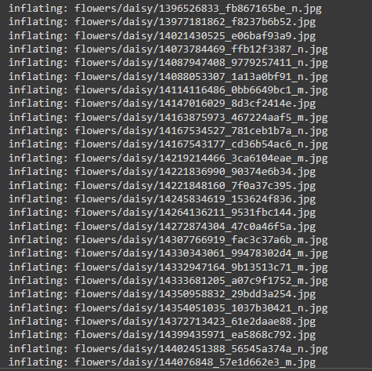



o #importing required libraries to build a CNN classification model with accuracy import numpy as np

import tensonflow as tf

from tensorflow.keras impont layers

from tensorflow.keras.models import Sequential import matplotlib.oyplot as plt

batch s1ze = 32 im height = 186 im width = 180

data dir - ”/content/flowens“

**Question-2.** Image Augmentation

**Solution:**

**from tensorflow.keras.preprocessing.image import ImageDataGenerator**

**train_datagen = ImageDataGenerator(rescale = 1./255, horizontal_flip = True, vertical_flip = True, z oom_range = 0.2)**

**x_train = train_datagen.flow_from_directory(r"/content/flowers", target_size = (64,64) , class_mode**

**= "categorical", batch_size = 100)**



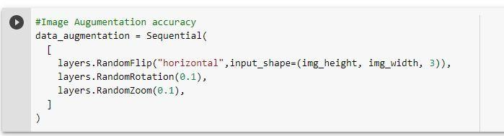

**Question-3.** Create model - Model Building and also Split dataset into training and testing sets

**Solution:**

**from tensorflow.keras.models import Sequential**

**from tensorflow.keras.layers import Convolution2D,MaxPooling2D,Flatten,Dense model = Sequential()**

**train_ds = tf.keras.utils.image_dataset_from_directory( data_dir,**

**validation_split=0.2, subset="training", seed=123,**

**image_size=(img_height, img_width), batch_size=batch_size)**



**val_ds = tf.keras.utils.image_dataset_from_directory( data_dir,**

**validation_split=0.2, subset="validation", seed=123,**

**image_size=(img_height, img_width), batch_size=batch_size)**



**class_names = train_ds.class_names print(class_names)**



**plt.figure(figsize=(10, 10))**

**for images, labels in train_ds.take(1): for i in range(9):**

**ax = plt.subplot(3, 3, i + 1) plt.imshow(images[i].numpy().astype("uint8")) plt.title(class_names[labels[i]])**

**plt.axis("off")**

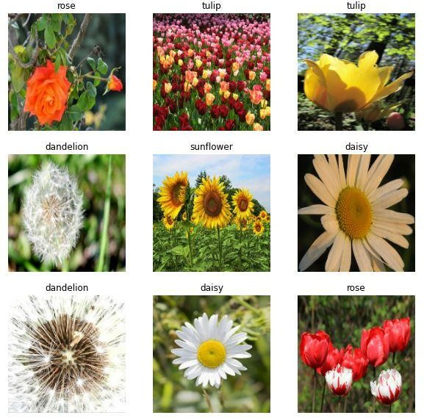

**Question-4.** Add the layers (Convolution,MaxPooling,Flatten,Dense-(HiddenLayers),Output)

**Solution:**

**model.add(Convolution2D(32, (3,3), activation = "relu", input_shape = (64,64,3) )) model.add(MaxPooling2D(pool_size = (2,2)))**

**model.add(Flatten()) model.add(Dense(300, activation = "relu"))**

**model.add(Dense(150, activation = "relu")) #mulitple dense layers model.add(Dense(5, activation = "softmax")) #output layer**

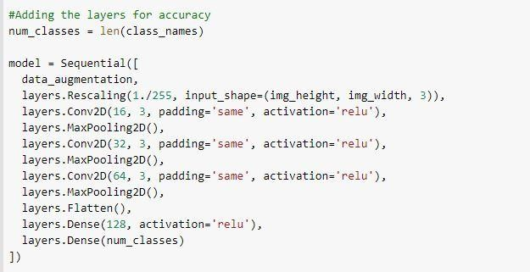

**Question-5.** Compile The Model

**Solution:**

**model.compile(loss = "categorical_crossentropy", metrics = ["accuracy"], optimizer = "adam") len(x_train)**

***#Compile the model for further accuracy***

**model.compile(optimizer='adam', loss=tf.keras.losses.SparseCategoricalCrossentropy(from_logits=True), metrics=['accuracy'])**

**epochs=10**

**history = model.fit( train_ds, validation_data=val_ds, epochs=epochs**

**)**

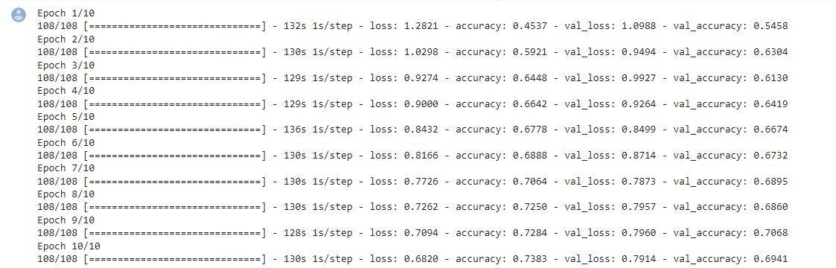

***#To find the Training and Validation- Accuracy & Loss (Visualization)***

**acc = history.history['accuracy']**

**val_acc = history.history['val_accuracy']**

**loss = history.history['loss'] val_loss = history.history['val_loss']**

**epochs_range = range(epochs) plt.figure(figsize=(8, 8))**

**plt.subplot(1, 2, 1)**

**plt.plot(epochs_range, acc, label='Training Accuracy') plt.plot(epochs_range, val_acc, label='Validation Accuracy') plt.legend(loc='lower right')**

**plt.title('Training and Validation Accuracy')**

**plt.subplot(1, 2, 2)**

**plt.plot(epochs_range, loss, label='Training Loss') plt.plot(epochs_range, val_loss, label='Validation Loss') plt.legend(loc='upper right')**

**plt.title('Training and Validation Loss') plt.show()**

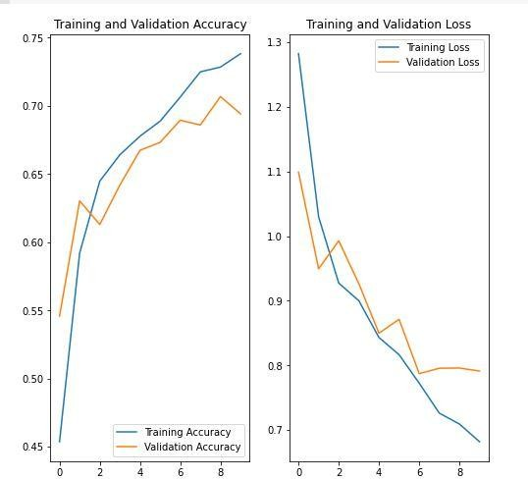

**Question-6.** Fit The Model

**Solution:**

**model.fit(x_train, epochs = 15, steps_per_epoch = len(x_train))**

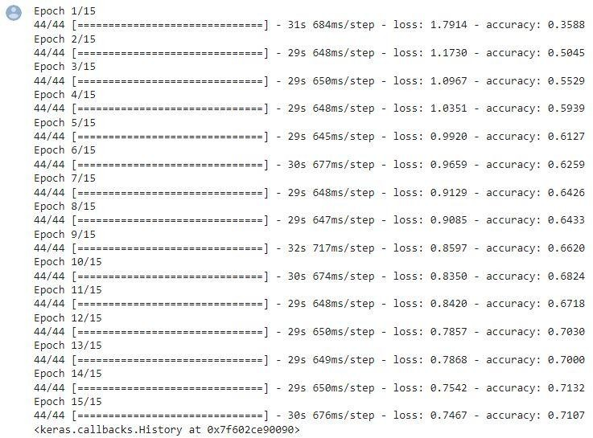

**Question-7.** Save The Model

**Solution:**

**model.save("flowers.h1")**

**model.save("flowers.m5")#another model to show the accuracy**

**Question-8.** Test The Model

**Solution:**

**from tensorflow.keras.models import load_model from tensorflow.keras.preprocessing import image import numpy as np**

**model = load_model("/content/flowers.h1")**

***# Testing with a random rose image from Google***

**img = image.load_img("/content/rose.gif", target_size = (64,64) )**

**img**



**x = image.img_to_array(img) x.ndim**

**x = np.expand_dims(x,axis = 0) x.ndim**

**pred = model.predict(x) pred**



**labels = ['daisy','dandelion','roses','sunflowers','tulips']**

**labels[np.argmax(pred)]**



***#Testing the alternative model with accuracy***

**sunflower_url = "https://storage.googleapis.com/download.tensorflow.org/example_images/592 px-Red_sunflower.jpg"**

**sunflower_path = tf.keras.utils.get_file('Red_sunflower', origin=sunflower_url) img = tf.keras.utils.load_img(**

**sunflower_path, target_size=(img_height, img_width)**

**)**

**img_array = tf.keras.utils.img_to_array(img)**

**img_array = tf.expand_dims(img_array, 0) *# Create a batch***

**predictions = model.predict(img_array) score = tf.nn.softmax(predictions[0]) print(**

**"This image most likely belongs to {} with a {:.2f} percent confidence."**

**.format(class_names[np.argmax(score)], 100 * np.max(score))**

**)**

